W.E. Skelton 4-H Educational Conference Center
at Smith Mountain Lake

Floyd County Junior 4-H Camp

June 26-30 2023

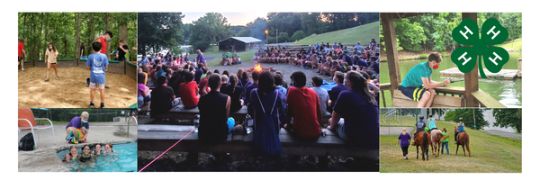

Join Floyd County 4-H for camp this summer!
What Is 4-H camp?
4-H camp Is a fun, safe and challenging experience for youth.
4-H camp Is planned and supervised by trained paid and volunteer staff with a ratio of not more than one counselor to seven campers.
4-H Junior Camp Is the place…
Please do not send money or forms to your child’s school!
All information should be sent to the 4-H Office.
209 Fox St. NW
Floyd, VA 24091
- For making new friends.
- For building confidence.
- For learning new skills.
- For creating memories.
Ages: 9-13
Registration Requirements:
- Completed Interest Form (linked above & by QR code) by February 1st
- Enroll In 4-H: https://v2.4honline.com
- Complete Camp Registration (Will be sent via Email): Camp spots are limited and will be reserved on a first-come-first serve basis.
- Complete additional required forms
- Camp Payment: $350 (Including lodging, meals and activities)
*If you are Interested In applying for financial assistance, you must contact the 4-H office at 745-9307 to receive the application. All money will be allocated before the final registration deadline.

Camp Interest Form:
Are you interested in 4-H camp?
Please use the Google form link below (By February 1) to receive registration information via email: https://forms.gle/cNe5f4eQiLxnVEKk8
or contact
Laura Jeuck, 4-H Agent
Sutphinl@vt.edu
540-745-9307
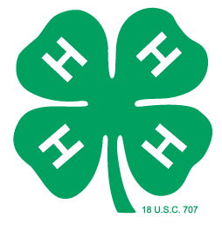

Scan to
Access Interest Form
@FloydCounty4H

